* Lognormal distribution. This distribution is positive and right-skewed, meaning majority of the values are relatively medium-small but large values are still possible with lower probabilities. Because it fits the characteristics of the individual claim severity which is positive amount with majority medium-to-small sized claims but few large claims, it is wide used in the actuarial practice. Lognormal distribution is heavy-tailed.

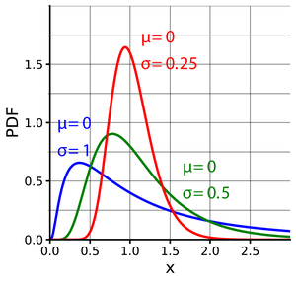

Figure 1: Probability density function (PDF) lognormal distribution with different parameters. (From Wikipedia)

* Normal distribution (aka Gauss distribution). It is the most common distribution for continuous random variable. In classic investment models such as Black–Scholes framework, the normal distribution is used to model the Investment yield. A disadvantage of normal distribution is that it’s not a heavy tail distribution so it under-estimates the probability of “black swam” events.

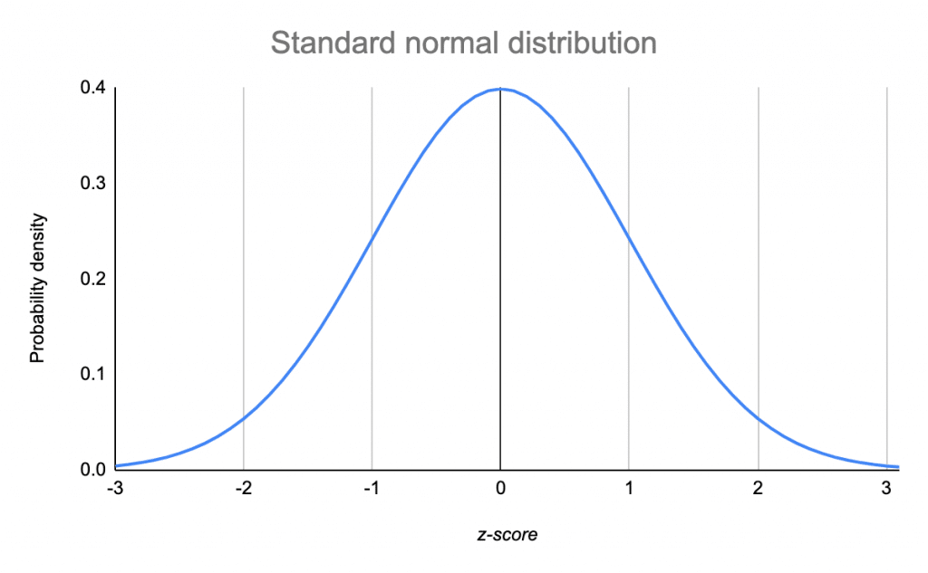

Figure2: PDF of normal distribution. (From scribbr.com)

* Pareto distribution. If the probability of loss decreases when the loss severity increases, then Pareto distribution is a good choice. It’s also a heavy-tailed distribution.

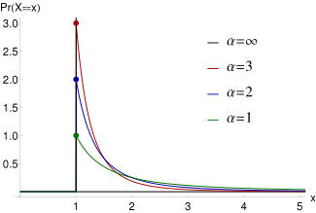

Figure 3: PDF of Pareto distribution with $x_{m}=1$ and different $α$ values. (From Wikipedia)

* Exponential distribution. It’s not a heavy-tailed distribution, but has similar PDF plot as Pareto distribution.

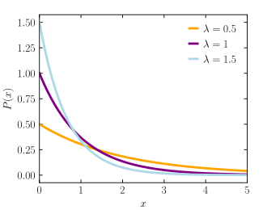

Figure 4: PDF of exponential distribution with different parameters. (From Wikipedia).

* Gamma distribution. It’s a light-tailed distribution. The exponential distribution is a special case of Gamma distribution. It’s a good choice for losses with right-skewed and light-tailed distribution.

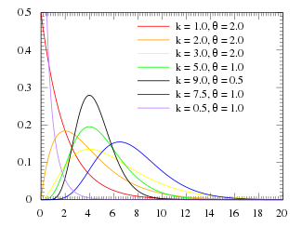

Figure 5: PDF of Gamma distribution with different parameters. (From Wikipedia).

* t-distribution. It’s symmetric as normal distribution, but heavy-tailed. It works better than normal distribution to describe the tail risk of investment yield.

Figure 6: PDF of t-distribution with different parameters. (From Wikipedia).